Applied Mathematics
The Derivative of Gradient Descent
In gradient descent, the beauty of learning with the equation that has the form of A X = A - Y, always a minus because what we need to do is to minimize the function, so when we use the derivative and it gives a minus we know that function value is decreasing and we have to move to the right to continue is decrease (the x^2) function. Moving to the right means that the input value has to increase which is what’s actually happening with the (X = A - - Y == X = A + B) so the input (x) is increasing. the same is true when the derivative is positive, which means that the value of the (x^2) function is increasing, hence we need to move in the opposite direction or we need to make X value smaller, so the equation X = A – V is doing that precisely since Y is a positive value.
Probability Distributions
For discrete values, the Khan 3 coin toss video which resulted in a (Histogram) like distribution for the number of heads that can appear along with the probability (1/8, 3/8…etc.).
For continuous values, we use a probability distribution function which can best fit the distribution of our data. It is a function rather than a histogram, data points might not 100% fit that distribution, but by adjusting the parameters, we can find the distribution that better fits the data or minimizes the errors (maximum likelihood methods?). Most famous ones are the normal distribution, the exponential distribution, the constant distribution…etc.

Calculus
Linear Algebra
Derivation
Multi-variable calculus
Regression
Linear Regression
Linear regression finds the straight line, called the least squares regression line or LSRL, that best represents observations in a bivariate data set. Suppose Y is a dependent variable, and X is an independent variable. Then, the equation for the regression line would be:
ŷ = b₀ + b₁x
where b₀ is a constant, b₁ is the regression coefficient, x is the value of the independent variable, and ŷ is thepredicted value of the dependent variable.
Normally, you will use a computational tool - a software package (e.g., Excel) or a graphing calculator - to find b₀and b₁. You enter the X and Y values into your program or calculator, and the tool solves for each parameter.
In the unlikely event that you find yourself on a desert island without a computer or a graphing calculator, you can solve for b₀ and b₁ "by hand". Here are the equations.
$$b1 = Σ [ (xi - \overline{x}) (yi - \overline{y})] / Σ [ (xi - \overline{x})2]$$
and
$$b0 = \overline{y} - b1 * \overline{x}$$

where b₀ is the constant in the regression equation, b₁ is the regression coefficient, x_{i} is the X value of observation i, y_{i} is the Y value of observation i, and x and y are the means of X and Y, respectively.
Logistic Regression
Gradient Descent
Matrices
Invert Matrix
Identity Matrix
Matrix Multiplication, addition
Vectors
Dimension Reduction
SVD
PCA, Principle Component Analysis
Eigen Vectors, values
Probability
Probability is often associated with at least one event. This event can be anything. Toy examples of events include rolling a die or pulling a colored ball out of a bag. In these examples the outcome of the event is random (you can’t be sure of the value that the die will show when you roll it), so the variable that represents the outcome of these events is called a random variable (often abbreviated to RV).

The 3 types of probability
- Marginal Probability: If A is an event, then the marginal probability is the probability of that event occurring, P(A). Example: Assuming that we have a pack of traditional playing cards, an example of a marginal probability would be the probability that a card drawn from a pack is red: P(red) = 0.5.
- Joint Probability: The probability of the intersection of two or more events. Visually it is the intersection of the circles of two events on a Venn Diagram (see figure below). If A and B are two events, then the joint probability of the two events is written as P (A ∩ B). Example: the probability that a card drawn from a pack is red and has the value 4 is P (red and 4) = 2/52 = 1/26. (There are 52 cards in a pack of traditional playing cards and the 2 red ones are the hearts and diamonds). We’ll go through this example in more detail later.
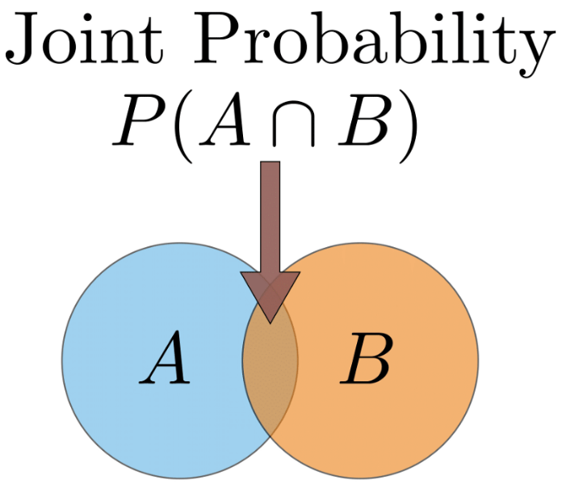
- Conditional Probability: The conditional probability is the probability that some event(s) occur given that we know other events have already occurred. If A and B are two events, then the conditional probability of A occurring given that B has occurred is written as P(A|B). Example: the probability that a card is a four given that we have drawn a red card is P(4|red) = 2/26 = 1/13. (There are 52 cards in the pack, 26 are red and 26 are black. Now because we’ve already picked a red card, we know that there are only 26 cards to choose from, hence why the first denominator is 26).

Linking the probability types, the general multiplication rule:

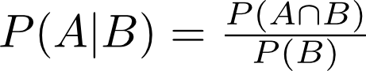

Further Explanation of the Examples
Sometimes distinguishing between the joint probability and the conditional probability can be quite confusing, so using the example of picking a card from a pack of playing cards let’s try to hammer home the difference.
In the case where we want to find the probability of picking a card that is red and a 4 i.e. the joint probability P (red and 4) I want you to imagine having all 52 cards face down and picking one at random. Of those 52 cards, 2 of them are red and 4 (4 of diamonds and 4 of hearts). So the joint probability is therefore 2/52 = 1/26.
In the case where we want to find the probability of picking a card that is 4 given that I know the card is already red i.e. the conditional probability, P(4|red), I want you to again imagine having all 52 cards. However, before picking a card at random you sort through the cards and select all of the 26 red ones. Now you put those 26 cards face down and pick a card randomly. Again, 2 of those red cards are 4’s so the conditional probability is 2/26 = 1/13.

P(Red)=26/52
P (Red and 4) = 2/52

P (4) =4/52

Joint = 2/52 = 1/26
Conditional = 2/26=1/13, by the rule.

Probability rules: ‘and’ and ‘or’
‘and’ rule
We’ve already seen the ‘and’ scenario disguised as joint probability, however we don’t yet know how to calculate the probability in the ‘and’ scenario. So let’s go through an example. Let’s suppose we have two events: event A — tossing a fair coin, and event B — rolling a fair die. We might be interested in knowing the probability of rolling a 6 and the coin landing on heads. So to calculate the joint probability of rolling a 6 and the coin landing heads we can rearrange the general multiplication rule above to get P (A ∩ B) = P(A|B) ✕ P(B). We know that event A is tossing a coin and B is rolling a die. So P(A|B) term asks “what is the probability of the coin landing on heads given that I’ve rolled a 6 on the die?” This is where we intuitively understand that the outcome of tossing the coin doesn’t depend on the roll of the die. The events are said to be independent. In this scenario the result of the coin toss would be the same no matter what we rolled on the die. Mathematically we express this as P(A|B) = P(A). Therefore, when the events are independent, the joint probability is just the product of the individual marginal probabilities of the events: P (A ∩ B) = P(A) ✕ P(B). So P (coin landing heads and rolling a 6) = P (A=heads, B=6) = 1/2 ✕ 1/6 = 1/12.
Notice that I wrote P (A=heads, B=6). The comma between the events is shorthand for joint probability (you will see this written in the literature).
It should be noted that in many real world scenarios events are assumed to be independent even when this is not the case in reality. This is mainly because it makes the math a lot easier. The bonus is that the results are often very useful. The Naive Bayes’ method is possibly the most common example of this in data science and typically gives fairly good results in classification problems.
‘or’ rule
With the ‘and’ rule we had to multiply the individual probabilities. When we’re in the ‘or’ scenario we have to add the individual probabilities and subtract the intersection. Mathematically we write this as P (A ∪ B) = P(A) + P(B) - P (A ∩ B). Why do we have to do this you ask? Well it goes back to the Venn diagram in the above figure. If we add the circle for A and the circle for B, then it means that we’re adding the intersection twice. Therefore, we need to subtract the intersection.
So let’s change our example above to find the probability of rolling a 6 or the coin landing on heads. This is P (coin landing heads or rolling a 6) = P (A=heads ∪ B=6) = 1/2 + 1/6 - 1/12 = 6/12 + 2/12 - 1/12 = 7/12
Note that the ∪ symbol is known as ‘union’ and is used in the ‘or’ scenario.
There are occasions when we don’t have to subtract the intersection. This happens when the two circles in the Venn diagram don’t overlap. When the circles for two events do not overlap we say that these events are mutually exclusive. This implies that the intersection is zero, written mathematically as P (A ∩ B) = 0. Let’s do an example that covers this case. Suppose we roll a die and we want to know the probability of rolling a 5 or a 6. These events are mutually exclusive because we can’t roll a 5 and a 6. Therefore, their circles in a Venn diagram do not overlap. So the probability of rolling a 5 or a 6 is equal to 1/6 + 1/6 = 2/6 = 1/3 (we haven’t subtracted anything).
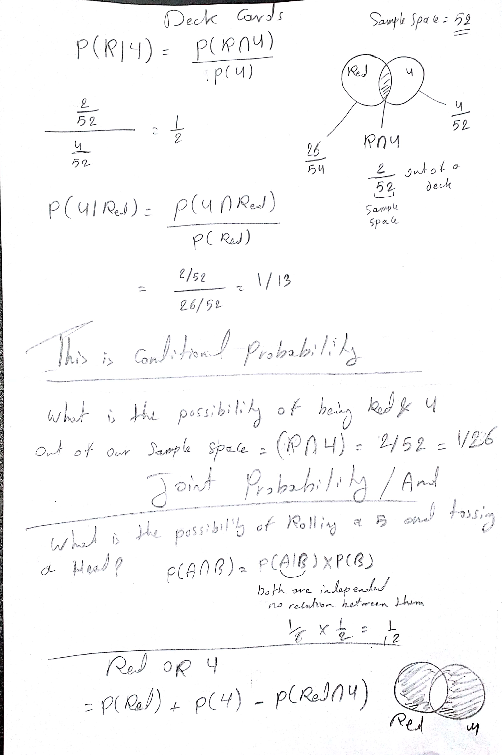

https://towardsdatascience.com/probability-concepts-explained-introduction-a7c0316de465

Probability Distribution
Continuous Probability Distribution
Joint Probability Distribution
Bernoulli distribution
Poison Distribution
Maximum Likelihood
Maximum likelihood estimation is a method that determines values for the parameters of a model. The parameter values are found such that they maximize the likelihood that the process described by the model produced the data that were actually observed.
The above definition may still sound a little cryptic so let’s go through an example to help understand this.
Let’s suppose we have observed 10 data points from some process. For example, each data point could represent the length of time in seconds that it takes a student to answer a specific exam question. These 10 data points are shown in the figure below

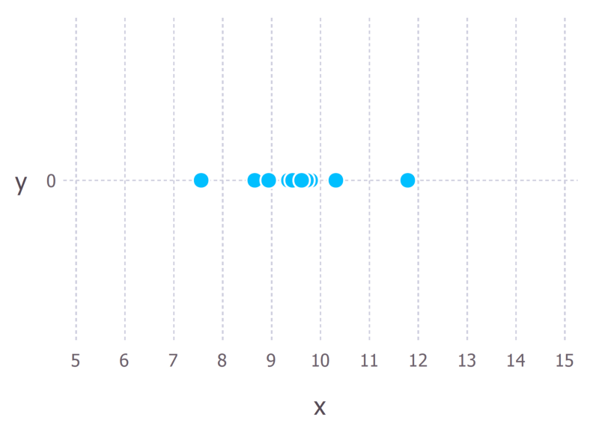
We first have to decide which model we think best describes the process of generating the data. This part is very important. At the very least, we should have a good idea about which model to use. This usually comes from having some domain expertise but we won’t discuss this here.
For these data we’ll assume that the data generation process can be adequately described by a Gaussian (normal) distribution. Visual inspection of the figure above suggests that a Gaussian distribution is plausible because most of the 10 points are clustered in the middle with few points scattered to the left and the right. (Making this sort of decision on the fly with only 10 data points is ill-advised but given that I generated these data points we’ll go with it).
Recall that the Gaussian distribution has 2 parameters. The mean, μ, and the standard deviation, σ. Different values of these parameters result in different curves (just like with the straight lines above). We want to know which curve was most likely responsible for creating the data points that we observed? (See figure below). Maximum likelihood estimation is a method that will find the values of μ and σ that result in the curve that best fits the data.
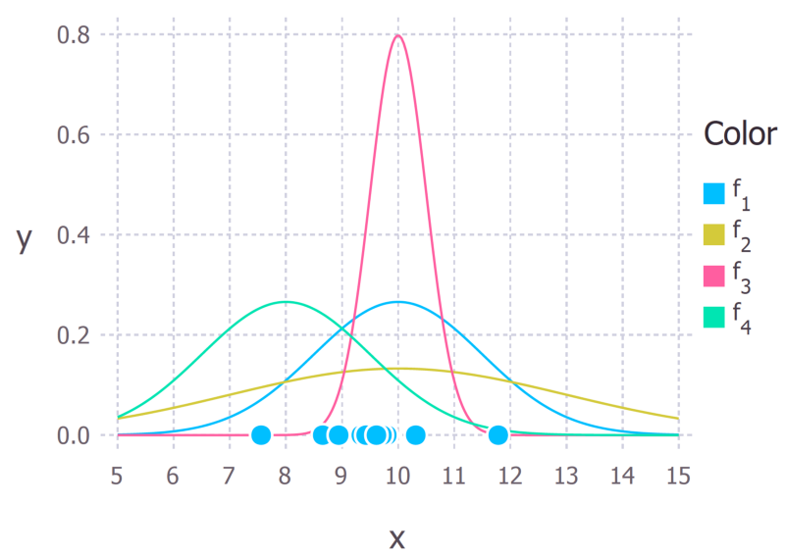
The 10 data points and possible Gaussian distributions from which the data were drawn. f1 is normally distributed with mean 10 and variance 2.25 (variance is equal to the square of the standard deviation), this is also denoted f1 ∼ N (10, 2.25). f2 ∼ N (10, 9), f3 ∼ N (10, 0.25) and f4 ∼ N (8, 2.25). The goal of maximum likelihood is to find the parameter values that give the distribution that maximize the probability of observing the data.

The true distribution from which the data were generated was f1 ~ N (10, 2.25), which is the blue curve in the figure above.
Calculating the Maximum Likelihood Estimates
Now that we have an intuitive understanding of what maximum likelihood estimation is we can move on to learning how to calculate the parameter values. The values that we find are called the maximum likelihood estimates (MLE).
Again we’ll demonstrate this with an example. Suppose we have three data points this time and we assume that they have been generated from a process that is adequately described by a Gaussian distribution. These points are 9, 9.5 and 11.
How do we calculate the maximum likelihood estimates of the parameter values of the Gaussian distribution μ and σ?
What we want to calculate is the total probability of observing all of the data, i.e. the joint probability distribution of all observed data points. To do this we would need to calculate some conditional probabilities, which can get very difficult. So it is here that we’ll make our first assumption. The assumption is that each data point is generated independently of the others. This assumption makes the maths much easier. If the events (i.e. the process that generates the data) are independent, then the total probability of observing all of data is the product of observing each data point individually (i.e. the product of the marginal probabilities).
The probability density of observing a single data point x, that is generated from a Gaussian distribution is given by:
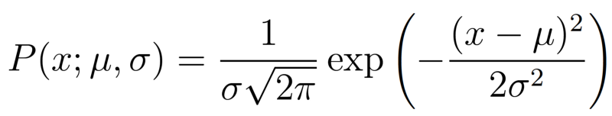
The semi colon used in the notation P (x; μ, σ) is there to emphasize that the symbols that appear after it are parameters of the probability distribution. So it shouldn’t be confused with a conditional probability (which is typically represented with a vertical line e.g. P (A| B)).
In our example the total (joint) probability density of observing the three data points is given by:
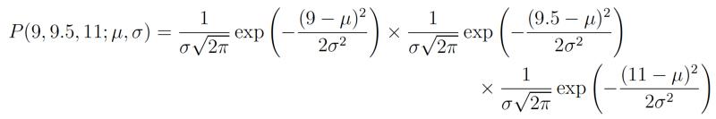
We just have to figure out the values of μ and σ that results in giving the maximum value of the above expression.
If you’ve covered calculus in your math’s classes, then you’ll probably be aware that there is a technique that can help us find maxima (and minima) of functions. It’s called differentiation. All we have to do is find the derivative of the function, set the derivative function to zero and then rearrange the equation to make the parameter of interest the subject of the equation. And voilà, we’ll have our MLE values for our parameters. I’ll go through these steps now but I’ll assume that the reader knows how to perform differentiation on common functions. If you would like a more detailed explanation, then just let me know in the comments.
The log likelihood
The above expression for the total probability is actually quite a pain to differentiate, so it is almost always simplified by taking the natural logarithm of the expression. This is absolutely fine because the natural logarithm is a monotonically increasing function. This means that if the value on the x-axis increases, the value on the y-axis also increases (see figure below). This is important because it ensures that the maximum value of the log of the probability occurs at the same point as the original probability function. Therefore, we can work with the simpler log-likelihood instead of the original likelihood.
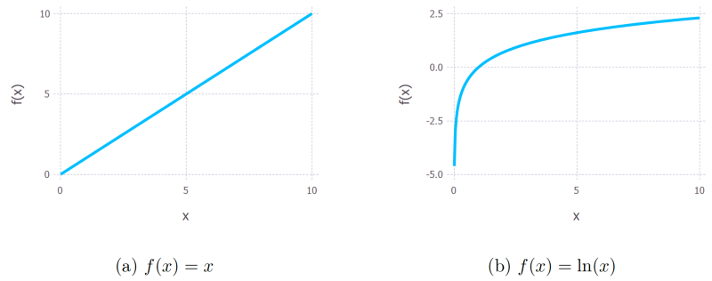
Monotonic behavior of the original function, y = x on the left and the (natural) logarithm function y = ln(x). These functions are both monotonic because as you go from left to right on the x-axis the y value always increases.
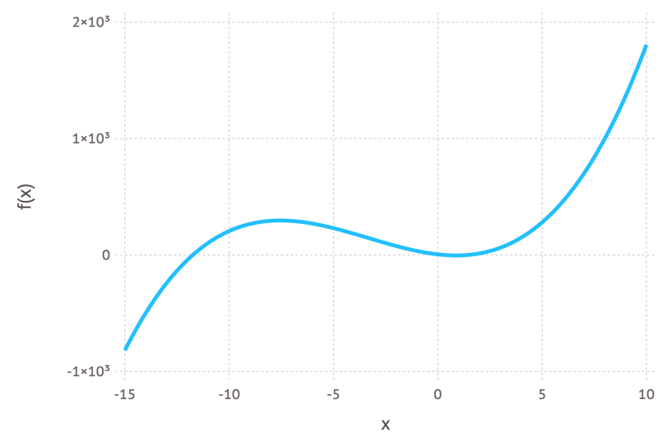
Example of a non-monotonic function because as you go from left to right on the graph the value of f(x) goes up, then goes down and then goes back up again.
Taking logs of the original expression gives us:
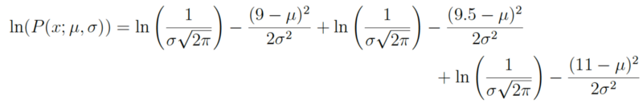
This expression can be simplified again using the laws of logarithms to obtain:
This expression can be differentiated to find the maximum. In this example we’ll find the MLE of the mean, μ. To do this we take the partial derivative of the function with respect to μ, giving

Finally, setting the left hand side of the equation to zero and then rearranging for μ gives:

And there we have our maximum likelihood estimate for μ. We can do the same thing with σ too but I’ll leave that as an exercise for the keen reader.
Can maximum likelihood estimation always be solved in an exact manner?
No is the short answer. It’s more likely that in a real world scenario the derivative of the log-likelihood function is still analytically intractable (i.e. it’s way too hard/impossible to differentiate the function by hand). Therefore, iterative methods like Expectation-Maximization algorithms are used to find numerical solutions for the parameter estimates. The overall idea is still the same though.
So why maximum likelihood and not maximum probability?
Well this is just statisticians being pedantic (but for good reason). Most people tend to use probability and likelihood interchangeably but statisticians and probability theorists distinguish between the two. The reason for the confusion is best highlighted by looking at the equation.
These expressions are equal! So what does this mean? Let’s first define P (data; μ, σ)? It means “the probability density of observing the data with model parameters μ and σ”. It’s worth noting that we can generalize this to any number of parameters and any distribution.
On the other hand, L (μ, σ; data) means “the likelihood of the parameters μ and σ taking certain values given that we’ve observed a bunch of data.”
The equation above says that the probability density of the data given the parameters is equal to the likelihood of the parameters given the data.
But despite these two things being equal, the likelihood and the probability density are fundamentally asking different questions — one is asking about the data and the other is asking about the parameter values. This is why the method is called maximum likelihood and not maximum probability.

When is least squares minimization the same as maximum likelihood estimation?
Least squares minimization is another common method for estimating parameter values for a model in machine learning. It turns out that when the model is assumed to be Gaussian as in the examples above, the MLE estimates are equivalent to the least squares method. For a more in-depth mathematical derivation check out these slides.
Intuitively we can interpret the connection between the two methods by understanding their objectives. For least squares parameter estimation we want to find the line that minimizes the total squared distance between the data points and the regression line (see the figure below). In maximum likelihood estimation we want to maximize the total probability of the data. When a Gaussian distribution is assumed, the maximum probability is found when the data points get closer to the mean value. Since the Gaussian distribution is symmetric, this is equivalent to minimizing the distance between the data points and the mean value.
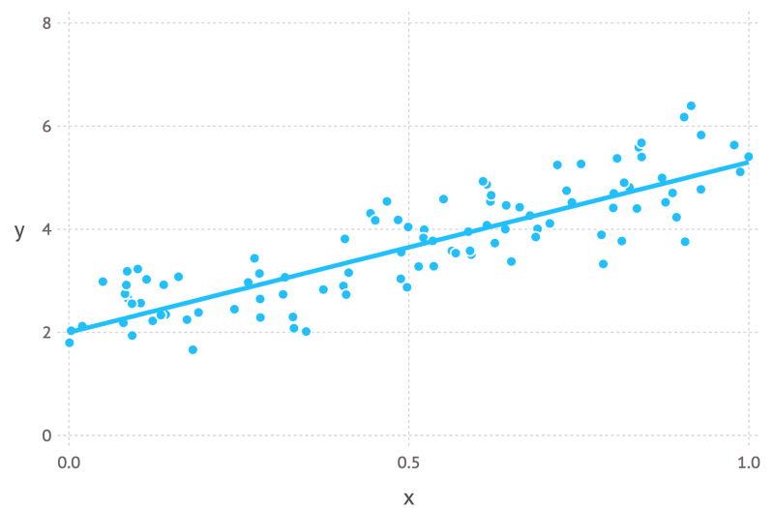
Regression line showing data points with random Gaussian noise
If there is anything that is unclear or I’ve made some mistakes in the above feel free to leave a comment. In the next post I plan to cover Bayesian inference and how it can be used for parameter estimation.
https://towardsdatascience.com/probability-concepts-explained-maximum-likelihood-estimation-c7b4342fdbb1
Bayes Theorem
Statistics
Neural Networks
Applied Machine Learning
Machine Learning
Neural Networks
Perceptron’s
Feed Forward Networks
Back Propagation
Deep Learning Concepts
In a deep learning neural network, each hidden layer is responsible for training the unique set of features based on the output of the previous layer. As the number of hidden layers’ increases, the complexity and abstraction of data also increase. It forms a hierarchy from low-level features to high-level features. With this, it becomes possible that a deep learning algorithm can be used to solve higher complex problems consisting of a large number of non-linear transformational layers.
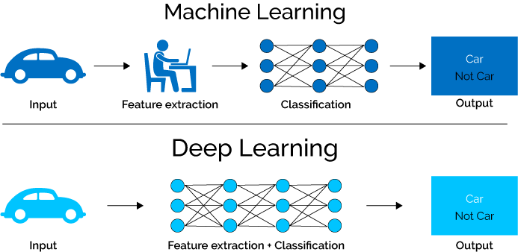
The traditional neural network consists of at most 2 layers and this type of structure of the neural network is not suitable for the computation of larger networks. Therefore, a neural network having more than 10 or even 100 layers is meant for deep learning. In this, a stack of the layer of neurons is developed. The lowest layer in the stack is responsible for the collection of raw data such as images, videos, text, etc. Each neuron of the lowest layer will store the information and pass the information further to the next layer of neurons and so on. As the information flows within the neurons of layers hidden information of the data is extracted. So, we can conclude that as the data moves from lowest layer to highest layer (moving deep inside the neural network) more abstracted information is collected.
Convolutional Neural Networks
Nice convolution network video
https://www.youtube.com/watch?v=2-Ol7ZB0MmU&t=1442s

Restricted Boltzmann Machines
Recurrent Neural Networks
SVM
Markov Theorem
Hidden Markov Model
Random Forest
Python
Networks

Generative VS Discriminative Models

MLEngineerFollow
Aug 30
I would like to start this write up with a story.

Story:
A father has two kids, Kid A and Kid B. Kid A has a special character whereas he can learn everything in depth. Kid B have a special character whereas he can only learn the differences between what he saw.
One fine day, The father takes two of his kids (Kid A and Kid B) to a zoo. This zoo is a very small one and has only two kinds of animals say a lion and an elephant. After they came out of the zoo, the father showed them an animal and asked both of them “is this animal a lion or an elephant?”
The Kid A, the kid suddenly draw the image of lion and elephant in a piece of paper based on what he saw inside the zoo. He compared both the images with the animal standing before and answered based on the closest match of image & animal, he answered: “The animal is Lion”.
The Kid B knows only the differences, based on different properties learned, he answered: “The animal is a Lion”.
Here, we can see both of them is finding the kind of animal, but the way of learning and the way of finding answer is entirely different. In Machine Learning, We generally call Kid A as a Generative Model & Kid B as a Discriminative Model.
In General, A Discriminative model ‌models the decision boundary between the classes. A Generative Model ‌explicitly models the actual distribution of each class. In final both of them is predicting the conditional probability P(Animal | Features). But Both models learn different probabilities.
A Generative Model ‌learns the joint probability distribution p(x,y). It predicts the conditional probability with the help of Bayes Theorem. A Discriminative model ‌learns the conditional probability distribution p(y|x). Both of these models were generally used in supervised learningproblems.
If you are unaware of joint probability & conditional probability, Please read it here.

In Math,
‌Training classifiers involve estimating f: X -> Y, or P(Y|X)

Generative classifiers
- Assume some functional form for P(Y), P(X|Y)
- Estimate parameters of P(X|Y), P(Y) directly from training data
- Use Bayes rule to calculate P(Y |X)

Discriminative Classifiers
- Assume some functional form for P(Y|X)
- Estimate parameters of P(Y|X) directly from training data

Examples:

Generative classifiers
- ‌Naïve Bayes
- Bayesian networks
- Markov random fields
- ‌Hidden Markov Models (HMM)

Discriminative Classifiers
- ‌Logistic regression
- Scalar Vector Machine
- ‌Traditional neural networks
- ‌Nearest neighbour
- Conditional Random Fields (CRF)s

Questions:
Ask yourself the following questions to get clear understanding about both these models.
- ‌ What are the problems these models can solve?
- ‌Which model learns joint probability?
- ‌Which model learns conditional probability?
- ‌What happens when we give correlated features in discriminative models?
- ‌What happens when we give correlated features in generative models?
- ‌Which models works very well even on less training data?
- Is it possible to generate data from with the help of these models?
- ‌Which model will take less time to get trained?
- ‌Which model will take less time to predict output?
- ‌Which model fails to work well if we give a lot of features?
- ‌Which model prone to overfitting very easily?
- ‌Which model prone to underfitting easily?
- ‌What happens when training data is biased over one class in Generative Model?
- ‌What happens when training data is biased over one class in Discriminative Models?
- ‌Which model is more sensitive to outliers?
- ‌Can you able to fill out the missing values in a dataset with the help of these models?
Here is a nice paper by Professor Andrew NG on Generative and Discriminative Models, Read it if you want to go deep.
https://medium.com/@mlengineer/generative-and-discriminative-models-af5637a66a3

Homepage
Upgrade


Joint Probability vs Conditional Probability
MLEngineerFollowing
Aug 31
Before getting into joint probability & conditional probability, We should more about events.

Event
An event is a set of outcomes(one or more) from an experiment. It can be like “Getting a Tail when tossing a coin is an event”, “Choosing a King from a deck of cards (any of the 4 Kings) is also an event”, “Rolling a 5 is an event” etc.
Events can be:
- Independent Each event is not affected by other events. Example: Tossing a coin two times. The outcome of tossing the coin for the first time will not affect the outcome of the second event.
- Dependent (also called Conditional) An event is affected by other events. Example: Drawing 2 Cards from a Deck. After taking one card from the deck there are fewer cards available, so the probabilities change!
- Mutually Exclusive Two events can’t happen at the same time. Example:We can play football & rugby at the same time in a same football ground.

Probability
Probability is the likelihood of an event occuring. Many events can’t be predicted with total certainty. The best we can say is how likely they are to happen, using the idea of probability.

‌Joint Probability
Joint probability is the likelihood of more than one event occurring at the same time P(A and B). The probability of event A and event B occurring together. It is the probability of the intersection of two or more events written as p(A ∩ B).
Example: The probability that a card is a four and red =p(four and red) = 2/52=1/26. (There are two red fours in a deck of 52, the 4 of hearts and the 4 of diamonds).

Conditions for Joint Probability
- One is that events X and Y must happen at the same time. Example:Throwing two dice simultaneously.
- The other is that events X and Y must be independent of each other. That means the outcome of event X does not influence the outcome of event Y.
Example: Rolling two Dice.
- If the following conditions met, then P(A∩B) = P(A) * P(B).
What will happen if we find the joint probability of two dependent events?
‌Let Event X is the probability there are clouds in the sky and Event Y is the probability that it rains. Everyone knows that rain comes from clouds. So rain can only fall when there are clouds in the sky. That means the presence of clouds will influence the chances of rain, and that means these two events are NOT independent!
Joint probability cannot be used to determine how much the occurrence of one event influences the occurrence of another event. There fore the joint probability of X and Y (two dependent events) will be P(Y).
Joint probability of two disjoint events will be 0 because both the events cannot happen together.
So, unless or until we find how much the occurrence of one event influences the occurrence of another event, We cannot properly find the joint probability of two events. In order to solve this, Conditional Probabilitycame to rescue us.

Conditional Probability
‌The conditional probability of an event B is the probability that the event will occur given the knowledge that an event A has already occurred. It is denoted by P(B|A).
So now, The joint probability of two dependent events becomes ‌P(A and B) = P(A)P(B|A)

Bayes Theorem
We know that,
P(A and B) = P(A)P(B|A) and P(B and A) = P(B)P(A|B)
When we equate this we will get, P(A)P(B|A) = P(B)P(A|B), then ‌
P(A|B) = P(A) P(B|A) / P(B)
This is the bayes theorem
‌It tells: how often A happens given that B happens, written P(A|B),
When we know: how often B happens given that A happens, written P(B|A)
and how likely A is on its own, written P(A)
and how likely B is on its own, written P(B)
In Machine Learning terms, Change A as Hypothesis and B as Evidence, then
‌P(A|B) = P(A) P(B|A) / P(B) becomes P(H|E) = P(H) P(E|H) / P(E)
‌This relates the probability of the hypothesis before getting the evidence P(H) — prior probability , to the probability of the hypothesis after getting the evidence P(H|E) — posterior probability. The factor that relates the two, P(E|H) P(E), is called the likelihood ratio.
Bayes Theorem states that “The posterior probability equals the prior probability times the likelihood ratio”.

Prior & Posterior Probability
- Posterior probability is the probability an event will happen after all evidence has been taken into account.
- Prior probability is the probability an event will happen before you takeany new evidence into account.
- You can think of posterior probability as an adjustment on prior probability
- Posterior = ( Likelihood * Prior ) / Evidence

Hypothesis, Evidence & Likelihood
- The hypothesis is your “guess” at what will occur. It is a testable assertion.
- Evidence will support or oppose the hypothesis.
- The Likelihood is the chance or probability that one thing will happen.
That’s it!!! Thanks for checking out my article. Raise your questions in the comments.
- Machine Learning
- Probability
- Bayesian Statistics
- Hypothesis
- Evidence
3 claps
• Following


MLEngineer
Machine Learning Engineer

Also tagged Hypothesis
The Nebular Hypothesis : Formation of Universe


Jyotiraditya
440

Also tagged Bayesian Statistics
Making Your Neural Network Say “I Don’t Know” — Bayesian NNs using Pyro and PyTorch


Paras Chopra
1.3K

Also tagged Bayesian Statistics
The naive Bayes classifier


Steven Liu
6
Responses

Be the first to write a response…
Mohammad Fasha
- Probability Distribution
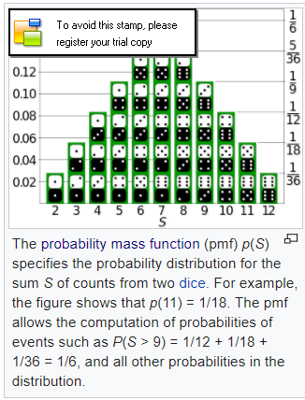
In probability theory and statistics, a probability distribution is a mathematical function that, stated in simple terms, can be thought of as providing the probabilities of occurrence of different possible outcomes in an experiment. For instance, if the random variable X is used to denote the outcome of a coin toss ("the experiment"), then the probability distribution of X would take the value 0.5 for X = heads, and 0.5 for X = tails (assuming the coin is fair).
In more technical terms, the probability distribution is a description of a random phenomenon in terms of the probabilities of events. Examples of random phenomena can include the results of an experiment or survey. A probability distribution is defined in terms of an underlying sample space, which is the set of all possible outcomes of the random phenomenon being observed. The sample space may be the set of real numbers or a higher-dimensional vector space, or it may be a list of non-numerical values; for example, the sample space of a coin flip would be {heads, tails} .

- Probability density function
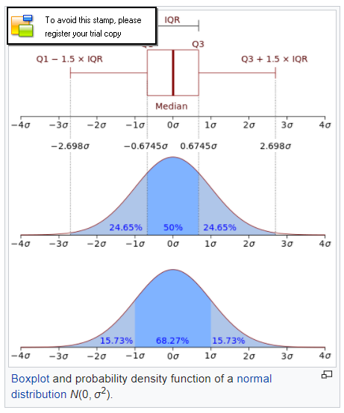
In probability theory, a probability density function (PDF), or density of a continuous random variable, is a function, whose value at any given sample (or point) in the sample space (the set of possible values taken by the random variable) can be interpreted as providing a relative likelihood that the value of the random variable would equal that sample
In other words, while the absolute likelihood for a continuous random variable to take on any particular value is 0 (since there are an infinite set of possible values to begin with), the value of the PDF at two different samples can be used to infer, in any particular draw of the random variable, how much more likely it is that the random variable would equal one sample compared to the other sample.

- Logistic Function
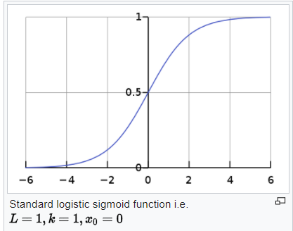
A logistic function or logistic curve is a common "S" shape (sigmoid curve), with equation:
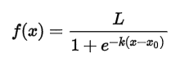
Where:
e = the natural logarithm base (also known as Euler's number),
x0 = the x-value of the sigmoid's midpoint,
L = the curve's maximum value, and
k = the steepness of the curve.

The standard logistic function is the logistic function with parameters (k = 1, x0 = 0, L = 1) which yields

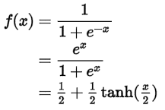

Logistic functions are used in logistic regression to model how the probability p of an event may be affected by one or more explanatory variables: an example would be to have the model

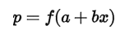
Logistic functions are often used in neural networks to introduce nonlinearity in the model and/or to clamp signals to within a specified range. A popular neural net element computes a linear combination of its input signals, and applies a bounded logistic function to the result; this model can be seen as a "smoothed" variant of the classical threshold neuron.
A common choice for the activation or "squashing" functions, used to clip for large magnitudes to keep the response of the neural network bounded is

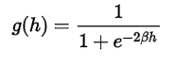

- Logistic Regression
Logistic regression is a statistical method for analyzing a dataset in which there are one or more independent variables that determine an outcome. The outcome is measured with a dichotomous variable (in which there are only two possible outcomes).
In logistic regression, the dependent variable is binary or dichotomous, i.e. it only contains data coded as 1 (TRUE, success, pregnant, etc.) or 0 (FALSE, failure, non-pregnant, etc.).
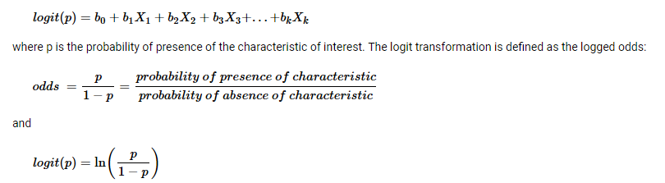

Rather than choosing parameters that minimize the sum of squared errors (like in ordinary regression), estimation in logistic regression chooses parameters that maximize the likelihood of observing the sample values.

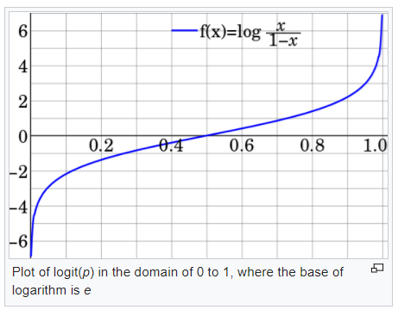
- Logit
The logit (/ˈloʊdʒɪt/ LOH-jit) function is the inverse of the sigmoidal "logistic" function or logistic transform used in mathematics, especially in statistics. When the function's variable represents a probability p, the logit function gives the log-odds, or the logarithm of the odds p/(1 − p).

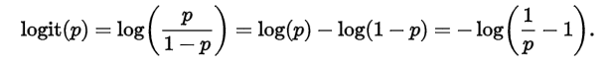

- Softmax
Softmax function, or normalized exponential function is a generalization of the logistic function that "squashes" a K-dimensional vector of arbitrary real values to a K-dimensional vector of real values in the range [0, 1] that add up to 1. The function is given by:

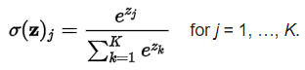

In probability theory, the output of the softmax function can be used to represent a categorical distribution – that is, a probability distribution over K different possible outcomes.
If we take an input of [1, 2, 3, 4, 1, 2, 3], the softmax of that is [0.024, 0.064, 0.175, 0.475, 0.024, 0.064, 0.175]. The output has most of its weight where the '4' was in the original input. This is what the function is normally used for: to highlight the largest values and suppress values which are significantly below the maximum value.

- Softmax regression
Softmax regression is a method in machine learning which allows for the classification of an input into discrete classes. Unlike the commonly used logistic regression, which can only perform binary classifications, softmax allows for classification into any number of possible classes.
Multinomial logistic regression
In statistics, multinomial logistic regression is a classification method that generalizes logistic regression to multiclass problems, i.e. with more than two possible discrete outcomes.That is, it is a model that is used to predict the probabilities of the different possible outcomes of a categorically distributed dependent variable, given a set of independent variables (which may be real-valued, binary-valued, categorical-valued, etc.).
Multinomial logistic regression is known by a variety of other names, including polytomous LR,[2][3] multiclass LR, softmax regression, multinomial logit, maximum entropy (MaxEnt) classifier, conditional maximum entropy model.
Multinomial logistic regression is used when the dependent variable in question is nominal(equivalently categorical, meaning that it falls into any one of a set of categories that cannot be ordered in any meaningful way) and for which there are more than two categories. Some examples would be:
- Which major will a college student choose, given their grades, stated likes and dislikes, etc.?
- Which blood type does a person have, given the results of various diagnostic tests?
- In a hands-free mobile phone dialing application, which person's name was spoken, given various properties of the speech signal?
- Which candidate will a person vote for, given particular demographic characteristics?
- Which country will a firm locate an office in, given the characteristics of the firm and of the various candidate countries?

- Cumulative distribution function
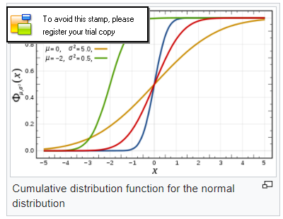
In probability theory and statistics, the cumulative distribution function (CDF) of a real-valued random variable X, or just distribution function of X, evaluated at x, is the probability that X will take a value less than or equal to x.
In the case of a continuous distribution, it gives the area under the probability density function from minus infinity to x. Cumulative distribution functions are also used to specify the distribution of multivariate random variables.
The cumulative distribution function of a real-valued random variable X is the function given by:

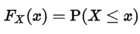

where the right-hand side represents the probability that the random variable X takes on a value less than or equal to x. The probability that X lies in the semi-closed interval (a, b], where a < b, is therefore:

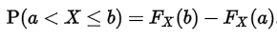

- Conditional Probability
In probability theory, conditional probability is a measure of the probability of an eventgiven that (by assumption, presumption, assertion or evidence) another event has occurred.[1] If the event of interest is A and the event B is known or assumed to have occurred, "the conditional probability of A given B", or "the probability of A under the condition B", is usually written as P(A|B), or sometimes PB(A). For example, the probability that any given person has a cough on any given day may be only 5%. But if we know or assume that the person has a cold, then they are much more likely to be coughing. The conditional probability of coughing given that you have a cold might be a much higher 75%.
P(A|B) may or may not be equal to P(A) (the unconditional probability of A). If P(A|B) = P(A) (or its equivalent P(B|A) = P(B)), then events A and B are said to be independent: in such a case, having knowledge about either event does not change our knowledge about the other event. Also, in general, P(A|B) (the conditional probability of A given B) is not equal to P(B|A). For example, if you have cancer you might have a 90% chance of testing positive for cancer. In this case what is being measured is that if event B ("having cancer") has occurred, the probability of A (test is positive) given that B (having cancer) occurred is 90%: that is, P(A|B) = 90%. Alternatively, if you test positive for cancer you may have only a 15% chance of actually having cancer because most people do not have cancer and the false positive rate for the test may be high. In this case what is being measured is the probability of the event B (having cancer) given that the event A (test is positive) has occurred: P(B|A) = 15%. Falsely equating the two probabilities causes various errors of reasoning such as the base rate fallacy. Conditional probabilities can be correctly reversed using Bayes' theorem.

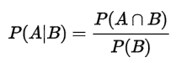

- Naive Bayes
Abstractly, naive Bayes is a conditional probability model: given a problem instance to be classified, represented by a vector representing some n features (independent variables), it assigns to this instance for each of k possible outcomes or classes

